**Expertise Wthin Working Memory and Fluid Intelligence**

**Working Memory**

Working memory has been a critical component to human cognition studies in the literature. Baddeley (1986) describes working memory (WM) as the temporary storage of stimuli being encoded. Working memory plays its biggest role as part of your short-term memory (STM). STM, defined by Baddeley (1986), is when you can hold a short amount of information for a limited time. STM works in an interacting system that serves higher level mental processes. These higher level mental processes include reasoning, problem-solving, and learning.

Baddeley and Hitch (1994) first proposed a working memory model in 1974. Their model included the idea of a phonological loop, visuospatial sketchpad, and central executive. The phonological loop (previously the articulatory loop) has two parts: phonological storage and subvocal rehearsal. Phonological storage is when a person holds a sound memory trace until this trace is then rehearsed by the subvocal rehearsal of the model by repeating the trace internally. Baddeley and Hitch’s memory model additionally includes a visuospatial sketchpad, which is primarily responsible for visual and spatial encoding. Visual encoding would be when you receive an incoming image or stimuli and your brain is recognizing it so you can respond appropriately. Baddeley and Hitch (1994) explain that the visuospatial sketchpad is a type of work space for incoming information. The final piece of their model is the central executive. The central executive is responsible for controlling when the phonological loop and visuospatial sketchpad are used, and how they interact with one another (Baddeley, 2002).

**Fluid Intelligence**

There are copious amounts of brain mechanisms that work into how much you can hold in your working memory. One factor is intelligence, specifically fluid intelligence (*gF*). Horn (1968) describes intelligence as behavior that can be observed and measured. Horn is describing that, for researchers in the behavioral sciences, intelligence needs to be measured in some aspect for it to be considered observable.. Jaeggi et al. (2008) classify *gF* as a human ability that allows participants to adapt their thinking to the problem at hand regardless of acquired knowledge. In addition, Gray, Chabris, and Braver (2003) highlight that *gF* is related to attentional control, or a person’s ability to disregard any interference that could affect performance. Gray et al. also say that attentional control is necessary for the abstract thinking needed for *gF.* Horn (1968) reports that Cattell presented the idea of *gF* in 1941 at an APA convention. Since then it has grown popular in the behavioral sciences as a way to measure intelligence that is always expanding. One of the primary ways to measure *gF* is to use the Raven’s Advanced Progressive Matrices (APM).

**Measuring of Working Memory and Fluid Intelligence**

Working memory has been tested in the field of psychology since Miller introduced the “magic number” in 1956. Yuan et al. (2006) suggest that there are two types of measurement: simple memory span and dual-tasks. Simple memory span tasks are when a participant is presented with a stimuli (words, numbers, or positions) and then asked to recall them in either the same or reversed order they were presented. Simple span tasks are generally used to measure short term memory (Mathy, Chekaf, & Cowan, 2018). Dual-trials tasks are when both processing and storage are both being encoded at the same time. Conway et al. (2005) identified most working memory measurements are considered dual-task because of their complexity. More modern working memory measurements are considered complex span tasks (Schmiedek, Hildebrandt, Lovden, Wilhelm, & Lindenberger, 2009). This distinction occurs because of the two components required for the task: the processing component and the storage component.

One of the most used tests to measure WM is the Operation Span (OSPAN) created by Turner and Engle (1989). In the OSPAN the participant is given a math problem which they have to identify the solution as correct or incorrect (processing component) with a word or letter being presented after they answer. The participant is then supposed to recall (storage component) those words after a few trials. The original OSPAN and the automated OSPAN (Unsworth, Heitz, Schrock, & Engle, 2005) still hold the same task, but the automated OSPAN is available completely online. This online presentation allows for less confounding variables between the researcher and the participant. The automated OSPAN also has a practice period where the participant is presented with a math problems. After the math practice, they are given a sample trial of math problem where they are told to remember a letter after answering whether the math problem was true or false. After both practice portions are completed the participant then begins the real study. The participants must maintain 85% accuracy for the math operations in order for their data to be considered useful (Unsworth et al., 2005). After the task is completed, the researcher is given the participants scores (Millisecond Software, 2016). The first is a raw score of the correctly recalled letters or words for each set. The researcher is also given a report on the participants math errors to account for accuracy.

Daneman and Carpenter’s (1980) Reading Span Task (RSPAN) is another example of a complex working memory measurement. The authors originally had two ways of testing reading span. In the first part of the RSPAN, participants read sentences out loud to the experimenter. After the participant finished a few sentences, they had to recall the last word in each sentence in order. For the second part, Daneman and Carpenter (1980) had the participant read sentences that were from general knowledge, politics, and other subjects; while still trying to remember the last word. After reading the sentence, the participant had to identify if the statement was true or false. The experimenters were interested in if the participant had recalled the words in order or not for the reading span; however, the true/false verification increased the difficulty of the task, much like the math problems in the OSPAN task. The participants are scored on the number of correct words they recalled in the correct order. For example, the participant is supposed to recall the words: tent, shoe, and bottle. If the participant recalled shoe and bottle, they would receive 2/3. It is important to note for this task that the order is crucial for scoring. For instance, if the participant recalled the same words as above in this order: shoe, tent, bottle, they would still only get a 2/3.

The N-Back task was created in the late 1950’s (Kirchner, 1958). The idea behind this task was to measure short-term memory retention. It consists of different visual stages presented to the participant (Gajewski et al., 2018). After a stimuli is presented, the participant is asked if it matches a stimuli that was presented *n* trails before it. For example, if the stimuli was presented with letters, and this pattern was shown: A, B, D, A. The participant would have to identify if the ‘A’ was presented three trials back. This would be considered a 3-back task because of the number of stimuli in-between the two matching pieces. The stimuli would keep being produced, and the participant would need to keep identifying if the same stimuli was presented before. This process can be repeated with different difficulties, starting with 1-back, the researcher would just increase the number of stimuli between the two stimuli you would want the participant to match. The *n-*back is scored by the reaction times and percentage correct correlated to those in the same age group as the participant. This task challenges the participant because it requires encoding and updating of incoming stimuli while irrelevant stimuli are being introduced (Gajewski et al., 2018).

The Raven Progressive Matrices (RPM) is a measure of *gF*. Raven (1936) initially wanted to develop a test that would allow the researchers to interpret it without any social barriers, as compared to the criticisms of other standardized intelligence tests. In 1988, it was updated and became the Raven’s Advanced Progressive Matrices (APM) (Bors, & Stokes, 1998). The participant is presented with several images that represent a complex pattern, and they must pick one of six or eight options that would complete the sequence. The images in the matrix may be rotated, flipped, or change in size. The APM consists of two sets. Set one has 12 items and is generally used as practice for the participant. Set two has 36 items that is more difficult than set one. The participant is scored by how many of their answers were correct. These raw scores are then compared to percentiles based on the participants age. Researchers can also choose to use a time restriction, five minutes for Set one or forty minutes for Set two (Bors, & Stokes, 1998). The time restricts could be used as an assessment of intellectual efficiency, without the time restrictions it can be used to evaluate clear thinking.

Conway et al. (2002) presented a latent variable analysis between WM, *gF*, STM, and processing speed. In their study, they had participants complete multiple simple and complex tasks including the OSPAN, RSPAN, and APM. They found that WM and *gF* were strongly linked, and that WM and STM were strongly linked, but *gF* was not linked to STM. The authors suggest that since WM is correlated with STM and *gF* is not, that WM and *gF* are different constructs that need different ways of being tested.

**Expertise**

The last construct that may affect your working memory or fluid intelligence is expertise. Chi, Glaser, and Rees (1982) describe expertise as having an abundance of knowledge and having skill to apply that knowledge. The authors argue that having this knowledge and skill plays a large part in intelligence as a whole. Because participants are able to recall their skill better and faster, they are perceived as more intelligent. This effect has been demonstrated primarily with the skillsets of chess (Chase & Simon, 1973) and physics (Chi, Feltovich & Glaser, 1981).

In Chase and Simon’s (1973) study on chess and memory, they had three classes of participants who played chess. From highest to lowest they were: master, Class A player, and beginner. The way the authors decided to study working memory was to isolate “chunks” that would then be encoded by the participant. These chunks were created by having a chess position set up having one of 28 variations. Chunks refer to Miller (1956) and his “magical number” 7, which proposes that most humans can contain 7 individual pieces of information plus or minus 2. During the memory task the players were asked to recall different chess positions from memory (Chase & Simon, 1973). The experimental design included two chess boards that were placed in front of the participant. These boards were recreated two ways. The first position was played games that were in the middle of a match and the second was from randomly placing the pieces on the board. The participant was told to examine the preset board for five seconds and recall the as much as they could remember on the full set board in front of them. The participant was able to repeat memorizing and recalling the board layout until they recalled the original set perfectly. It took those in the master class less trials than the Class A players and beginners to recreate the middle of the match positions. Those in the “master” class could encode the preset chess boards and recreate their model in less trials than the other two groups of participants, because they had more expertise playing chess. This finding suggests that the expertise influenced the results based off the position being a playable game or not.

Chi et al. (1981) looked at the same idea of expertise, but with those in the field of physics. For their categories of participants, they used PhD students in the physics department (experts) and undergraduates who had only completed one semester of a physics course (novices). They were given 24 problems to group together by the how the solution to the problem was to be found. All participants were interviewed after they separated the problems to their respective categories to see how they reasoned why that problem fits with the category they chose. They determined that the experts sorted by the laws of physics, and the novices sorted by surface structures. These surface structures refer to objects, terms, or configurations of the problem presented.

In the second part of the study, the experts and novices were presented a new set of 20 physic problems. This part of the study also included an intermediate participant who was a fourth-year physics major. These problems were created to include both physic laws and surface features combined to see how the participants would categorize them. The results were replicated from the previous study by the expert and the novice participants. Yet, the intermediate participant reasoned both by using the laws of physics and surface structures, showing that they had applied the laws, but not yet left the surface structure. These studies by Chase and Simon and Chi et al., demonstrate that expertise is perceptually learned through practice and understanding. They both demonstrate ideas of chunking (working memory) and previous knowledge (intelligence) that can lead to expertise.

**Interplay between these systems**

With these three constructs combined, WM, *gF,* and expertise, they could help shape how we understand stimuli storage in our short term or long-term memory. They each play an important part in how we view the world around us and evaluate everyday situations. Shelton et al. (2010) found in their study that WM was a predictor for *gF*. The authors did so by looking at multiple WM and *gF* tests and seeing how they correlated with processing speed, primary and secondary memory, WM and *gF*. After running a SEM model from the scores of all these tests, they found that processing speed, primary and secondary memory, and working memory all correlated with *gF*. They looked further into their SEM model to look at how much variance those constructs were explained by *gF*, and the authors found that WM had a unique variance when it came to predicting *gF* that none of the other constructs had. This supports that WM is primary component of *gF*.

Grabner, Neubauer, and Stern (2006) looked at the impact of intelligence and expertise on performance and neural efficiency. The authors recruited chess players for their study. The participants had to complete psychometric tests which included: the NEO-Five-Factor-Inventory, state anxiety test, a mood questionnaire, and the Intelligenz-Struktur-Test 2000 R for cognitive ability (Amthauer, R, 2001). These psychometric tests were used as a control for the EEG data collected. The participants also had to complete a speed, memory, and reasoning task using different types of chess boards and pieces on a computer while being monitored by an EEG. The authors found that the more intelligent participants had better performance than less intelligent participants in chess. There was an exception that those who were an expert at the task (chess in this study), could make up for a lower measured intelligence in other circumstances.

Template Theory (Gobet & Simon, 1996) uses the idea of templates, or patterns, which you (as a person or participant) can fill in different information at hand to complete problems (such as chess). These templates can also be chunks. LT-WMT (Ericsson & Kintsch, 1995) is described as the association of information that has been encoded and the retrieval cues in LTM. For chess, this would be remembering a certain cluster of pieces and being able to retrieve them and use them in a match. While in everyday life this could easily be after studying for long periods of time and seeing a definition to term question on an exam. Therefore, one could use TT with LT-WMT and as an expert, the LT is used as WM which would make that individuals memory storage and processing have higher processing (Guida et al., 2012).

Expertise works alongside WM and *gF* because it is needed to be able to recall and think about new problems at hand that the expert is evaluating. Without all three components it would be difficult for people work done efficiently. By looking at these three components together, the field of psychology may be able to achieve a better understanding of how WM, *gF*, and expertise interact. The multiple ways these components interact is important because it shapes our overall learning experience and everyday critical thinking.

**Method**

**Participants**

Participants were recruited from the Introductory Psychology course at Missouri State University. All participants were instructed to sign up through Missouri State’s participation system, SONA. There were two options for students to choose from, the control experiment (Insert title of study) or the foreign language portion (Insert title of study for those with experience in a second language). The participants who signed up for the foreign language section were required to have taken French, German, or Spanish for two years in High School, or be enrolled at the university in a foreign language course. There was a total of x participants, x% were female, x% were male, all between the ages of x-x. They received course credit for their participation in this study.

**Materials and Procedure**

All tasks were given to each participant at the same time. They were administered in groups of x. The order of tasks was counterbalanced for each section, control or foreign language, all tasks would be equal over the length of the experiment.

*Automated Operation Span (AOSPAN).* The AOSPAN was accessed through a Missouri State University domain. The AOSPAN consisted of three portions, two for practice: one of the letter recalls, the second with math problems, and last the full AOSPAN problems. The participant is prompted with the instructions explaining they will have to memorize letters and solve simple math problems. During the practice letter recall, they are shown black bold letters and told to remember the order in which they appear. For the math practice, they are given a math operation and told to identify whether the solution was true or false. For example, “IS 2X3 + 4 = 10” would be indicated as TRUE. After the practice portions, the participant then is prompted with the OSPAN instructions where they are told after they make their decision about whether the math operations answer is true or false, and that they must try to remember the letter that follows. The participant is told that it is important for them to answer the math operations quickly and accurately and must answer at least 85% of the problems correctly. The percent correct is displayed on the screen. There are 75 math problem and letter combinations, shown in sets of 2 to 7 problems with letter recall. To recall the letters, participants click on letters in order after the last problem-letter set. Participants are scored by the number of letters they correctly recall, and scores can range from 0 to 75. Participants who do not score about 85% will be not used in the study.

*Figure* . This screen demonstrates where the participant would order the letters from the recall after the math problem has been answered.

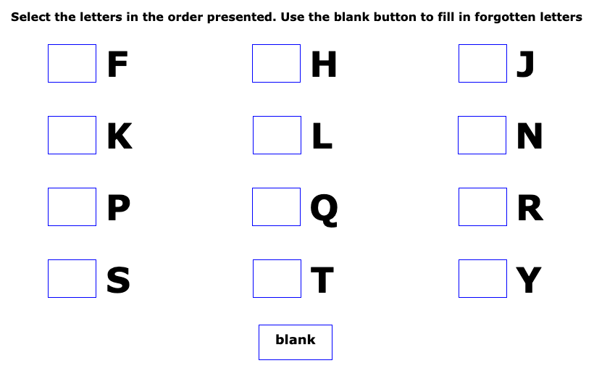

*Figure .* This screen shows an example of the math operations presented to the participant.

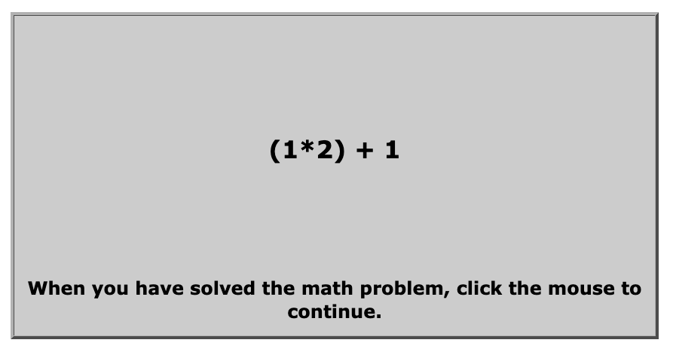

*Advanced Raven Progressive Matrices (APM).* The APM was setup through a Qualtrics survey for easier access. It consisted of three practice demonstrations. For example, in Figure X, the participant sees eight patterns that build on one another and then a blank box. They are told to complete the pattern by choosing one the eight patterns below the image that best fits the original pattern. Below that image is eight possible options that could complete the pattern. Since this is a practice problem, the participant is told that numbers 4, 6, and 7 cannot be correct because they only show one circle. The participant is also told that numbers 1, 3, and 5 cannot be correct because they only show two circles. The last thing they are told is that number 2 cannot be correct because it has too many circles. This leaves number 8 to be the correct option. All 36 matrices reflect this type of abstract thinking. After the participant completed the practice demonstrations, they started the APM. For the APM, it was required of the participant that they answer the current question before moving onward to the next. The participants completed Set Two of the APM, containing 36 problems and they had 25 minutes to complete it. Scores can range from 0 to 36.

*Figure .* This is the practice problem included in the instructions for the APM



*Typing Task.* The typing task is a words per minute typing task administered to all participants. It is a demonstration of expertise for those who do not have any foreign language experience. For this task, we used an online typing task ([www.TypingTest.com](http://www.TypingTest.com)). The participant completed a 1-minute typing test from this website, specifically the option the “Rules of Baseball.” The participants had one minute to type as quickly and accurately as possible. Figure X demonstrates the prompt participants had to type. The timer started as soon as the participant began typing. The website keeps track of any typing errors the participant may have committed. Figure X shows an example of the participants raw typing speed, errors, and adjusted speed. Their typing speed is on a scale from 0-100, ranging from slow to pro.

*Figure .* This figure is the prompt all participants had to type verbatim.

*Figure .* This figure shows the participants typing speed, errors, and adjusted speed.

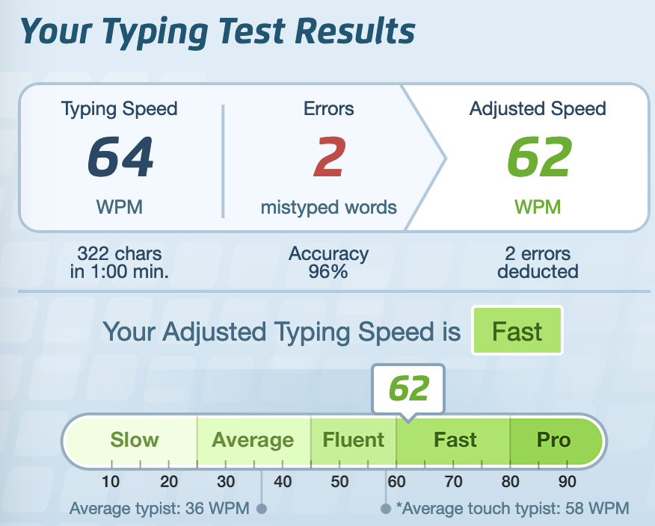

*Foreign Language Placement Exam.* This task was part of the experimental design for expertise. Participants would sign up for the foreign language portion. In addition to taking the typing task, the participants were also required to take Missouri State University’s Foreign Language Placement Exam given to those who wish to enroll in a foreign language course. The placement exam demonstrates proficiency in French, German, or Spanish. The entire exam is computerized and evaluates grammar, vocabulary, and reading comprehension in the above languages. For the reading comprehension questions, the participant is given a prompt in the second language and must answer a question about it (Figure X). After the exam is completed, they are given a score that represents which section of that language they should take (i.e., 101, 102, 201, 202 representing the four course sequence of foreign language requirement), and the point totals will be used as our measure of expertise. These scores will be translated into z-scores to be able to use a standardized metric for language expertise overall.

*Figure .* Example of a reading comprehension question in French.

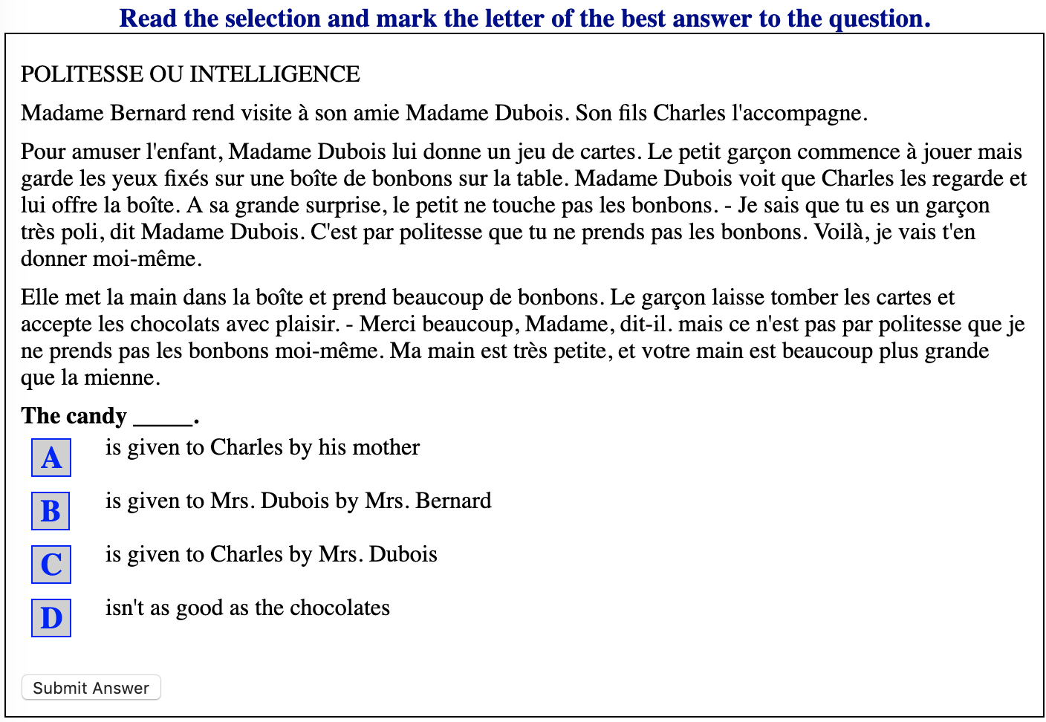

*Figure x-x.* These images demonstrate the amount of available points and the corresponding section the participant should take. In the following order are the points and sections assigned to that range of points for: French, German, and Spanish.

**Results**

Expertise and working memory studies have been done on various topics. Very few studies, however, include fluid intelligence and its relationship to expertise. This experiment was designed to compare expertise and working memory again, and then see how expertise and fluid intelligence are related as well. The hypothesis is that those who have a higher expertise in foreign language will have a higher working memory AOSPAN scores and higher fluid intelligence APM scores. For global expertise, we used the typing scores to correlate with AOSPAN, and APM to examine this hypothesis. As a second measure of expertise, we then looked at the correlation between foreign language fluency exam scores and working memory/fluid intelligence. Last, we compared the correlation between the typing scores and working memory/fluid intelligence to the same correlation for the language fluency and working memory/fluid intelligence. To control for correlated error (i.e., some people are in both correlations), we will use a multilevel model where the dependent variable is either working memory or fluid intelligence and the independent variables are expertise type (typing, language), expertise score, and their interaction with participant as a random intercept (Gelman, 2006). This analysis will examine if there are differences in relationships between these variables and the type of expertise, while controlling for participants repeated across conditions.

References

Amthauer, R., Brocke, B., Liepmann, D., Beauducel, A., Intelligenz- Struktur-Test 2000 R, Hogrefe, Gottingen, 2001.

Baddeley, A. D. (2002). Is working memory still working? *European Psychologist*, *7*(2), 85–97. https://doi-org.proxy.missouristate.edu/10.1027//1016-9040.7.2.85

Baddeley, A. D., & Hitch, G. J. (1994). Developments in the concept of working memory. *Neuropsychology*, *8*(4), 485–493. https://doi-org.proxy.missouristate.edu/10.1037/0894-4105.8.4.485

Cattell, R. B. (1963). Theory of fluid and crystallized intelligence: A critical experiment. *Journal of Educational Psychology*, *54*(1), 1–22.

Chase, W. G., & Simon, H. A., (1973). Perception in chess. *Cognitive Psychology, 4*(1), 55-81.

Chi, M., Feltovich, P., & Glaser, R., (1981). Categorization and Representation of Physics Problems by Experts and Novices. *Cognitive Science*, *5*(2), 121-152.

Conway, Andrew R. A., Cowan, B., Bunting, M. F., Therriault, D. J., & Minkoff, Scott R. B., (2002). A latent variable analysis of working memory capacity, short-term memory capacity, processing speed, and general fluid intelligence. *Intelligence*, 30, 163-183.

Geary, David. (2009). The evolution of general fluid intelligence. *Foundations in Evolutionary Cognitive Neuroscience*. 22-56. 10.1017/CBO9780511626586.002.

Gray, J. R., Chabris, C. F., & Braver, T.S (2003). Neural mechanisms of general fluid intelligence. *Nature*, 6(3), 316-322.

Horn, J. L. (1968). Organization of abilities and the development of intelligence. *Psychological Review*, *75*(3), 242–259. <https://doi.org/10.1037/h0025662>

Jaeggi, S. M., Buschkuehl, M., Perrig, W. J., & Meier, B., (2010). The concurrent validity of the *N*-back task as a working memory measure. *Memory*, 18:4, 394-412.

Kane, M. J., Hambrick, D. Z., Conway, A. R. A. (2005). Working memory capacity and fluid intelligence are strongly related constructs: Comment on Ackerman, Beier, and Boyle (2005). *Psychological Bulletin*, 131(1), 66-71.

Miller, G. A., (1956). The magical number seven, plus or minus two: Some limits on our capacity for processing information. *Psychological Review*, 63, 81-97.

<https://www.millisecond.com/download/library/v5/ospan/automatedospan.manual>

Redick, T.S., Broadway, J. M., Meier, M.E., Kuriakose, P.S., Unsworth, N., Kane, M. J., Engle, R.W., (2012). Measuring Working Memory Capacity With Automated Complex Span Tasks. *European Journal of Psychological Assessment* 28(3), 164-171

Robinson-Riegler, G., & Robinson-Riegler, B. (2004). *Cognitive psychology* (p. 157, 159, 506). Boston: Allyn and Bacon.

Shah, P., & Miyake, A. (1996). The separability of working memory resources for spatial thinking and language processing: An individual differences approach. *Journal of Experimental Psychology: General,* 125(1), 4–27.

Shelton, J. T., Elliott, E. M., Matthews, R. A., Hill, B. D., Grouvier, Wm. D. (2010). The relationships of working memory, secondary memory, and general fluid intelligence: Working memory is special. *Journal of Experimental Psychology: Learning, Memory, and Cognition,* 36(3), 813-820.

Unsworth, N., Engle, R. W., (2006). Simple and complex memory spans and their relation abilities: Evidence from list-length effects. *Journal of Memory and Language,* 54, 68-80.

Waugh, N. C., & Norman, D. A. (1965). Primary memory. *Psychological Review*, *72*(2), 89–104.

**Appendix**